SLF4J Logging Exercises

Name: Shubham Sangram Bej

Aim
To understand and implement logging in Java applications using the SLF4J (Simple Logging Facade for Java) framework along with Logback. The exercises demonstrate basic logging, parameterised logging, and configuring multiple appenders for console and file-based logging.

Objectives
- Understand the fundamentals of logging in Java applications.
- Learn how to integrate SLF4J with Logback.
- Implement error, warning, information, and debug logging.
- Perform parameterized logging for dynamic messages.
- Configure multiple appenders for console and file logging.
- Improve application monitoring and debugging using logging.

Software Requirements
- Java JDK 21
- IntelliJ IDEA 2026
- Apache Maven
- SLF4J API
- Logback Classic
- Git
- GitHub

Theory
SLF4J (Simple Logging Facade for Java) is a logging abstraction that provides a common interface for various logging frameworks. It allows developers to switch between different logging implementations without modifying application code. Logback is the default and one of the most widely used implementations of SLF4J. It offers powerful features including configurable log levels, parameterised logging, multiple appenders, and flexible output formatting. Logging plays a vital role in monitoring application behaviour, troubleshooting issues, and maintaining software systems efficiently.

Advantages
- Simplifies application debugging.
- Improves error tracking and monitoring.
- Supports multiple logging levels.
- Enables parameterised logging for better performance.
- Allows logging to both console and files.
- Easy integration with Java and Maven projects.
- Enhances maintainability of applications.
- Provides flexible logging configuration through Logback.

Exercises Performed

Exercise 1 – Logging Error Messages and Warning Levels

Description
A Java application was developed using SLF4J to demonstrate logging at different severity levels. Error and warning messages were logged using the SLF4J Logger interface.

Result
The application successfully displayed error and warning messages in the console.
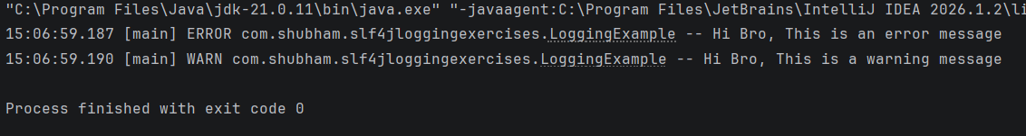

Exercise 2 – Parameterised Logging

Description
A Java application was created to demonstrate parameterised logging. Dynamic values such as user name and age were inserted into log messages using SLF4J placeholders ({}), resulting in cleaner and more efficient logging.

Result
The application successfully displayed parameterised log messages with the provided values.
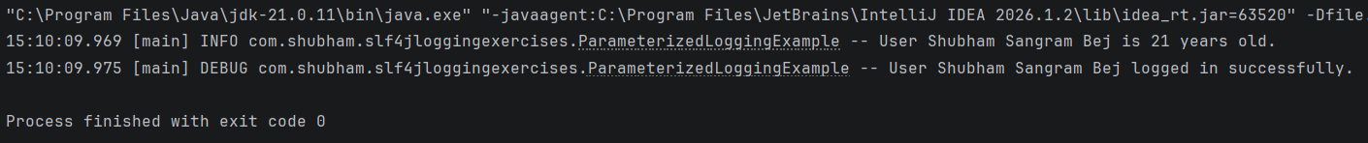

Exercise 3 – Using Different Appenders

Description
A Logback configuration file (logback.xml) was created to configure both Console and File appenders. The application generated log messages at multiple logging levels, which were displayed in the console and simultaneously written to the app.log file.

Result
The application successfully logged messages to both the console and the log file using different appenders.
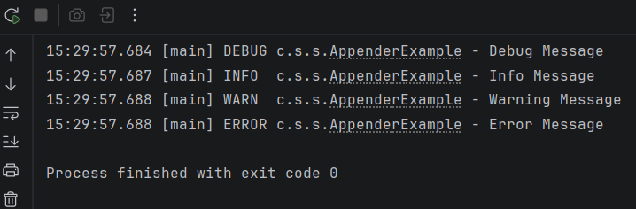

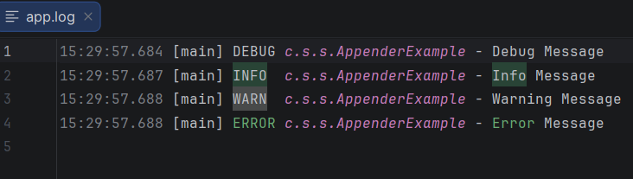

Project Structure
SLF4J-Logging-Exercises
│
├── src
│ ├── main
│ │ ├── java
│ │ │ └── com.shubham.slf4jloggingexercises
│ │ │ ├── LoggingExample.java
│ │ │ ├── ParameterizedLoggingExample.java
│ │ │ └── AppenderExample.java
│ │ │
│ │ └── resources
│ │ └── logback.xml
│
├── screenshots
├── README.md
├── pom.xml
└── app.log

Results
The following tasks were completed:
- Configured SLF4J and Logback using Maven.
- Implemented logging at different severity levels.
- Demonstrated parameterised logging using placeholders.
- Configured console and file appenders through logback.xml.
- Generated log output in both the IntelliJ console and the app.log file.
- Successfully executed all three exercises without errors.

Conclusion
The SLF4J Logging Exercises provided practical experience in implementing logging within Java applications using SLF4J and Logback. The exercises demonstrated how different logging levels can be used for application monitoring, how parameterized logging improves readability and performance, and how multiple appenders enable simultaneous logging to the console and files. These concepts are essential for developing robust, maintainable, and enterprise-level Java applications.

References
- SLF4J Official Documentation – https://www.slf4j.org/
- Logback Official Documentation – https://logback.qos.ch/
- Apache Maven Documentation – https://maven.apache.org/
- Oracle Java Documentation – https://docs.oracle.com/en/java/
- IntelliJ IDEA Documentation – https://www.jetbrains.com/idea/documentation/

